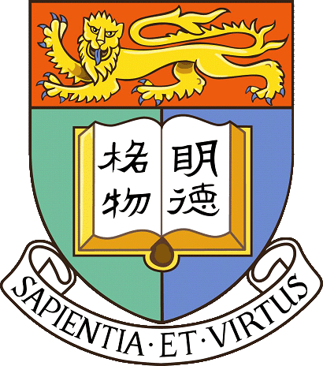
May 9, 2018 (Wednesday)
2:30 pm
Building 152, 2nd floor
The Office of International Affairs
Seoul National University

Research & Postgraduate Education at the University of Hong Kong
Dr Jetty Chung-Yung Lee (이충영 교수)
Assistant Professor
School of Biological Sciences
The University of Hong Kong

Studying and Living at the University of Hong Kong
Mr Kim Taihun (김태훈)
PhD Student, School of Biological Sciences
The University of Hong Kong

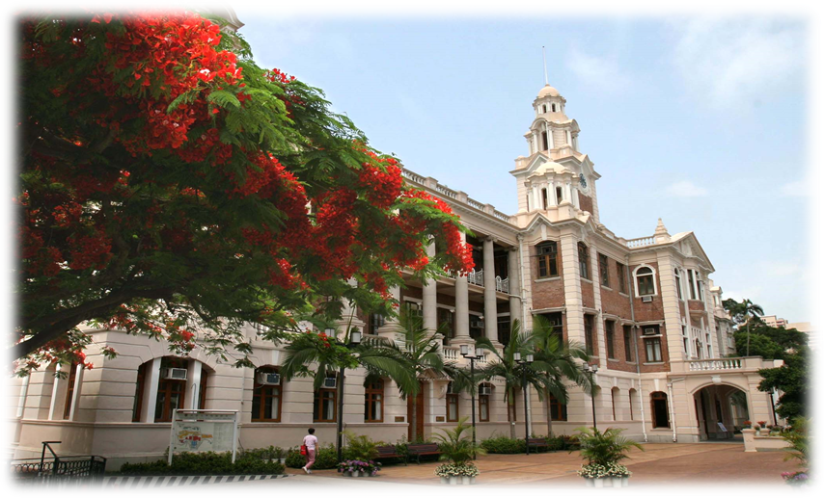
THE UNIVERSITY OF HONG KONG

Established in 1911, The University of Hong Kong (HKU) is recognized as a world-class comprehensive research university. It offers internationally recognized qualifications and it is renowned for its academic and research excellence worldwide. As an English-medium university in China, HKU also offers researchers unique opportunities to bridge cultures and continents. There are 10 Faculties and around 45 academic departments and schools that engage in multi-disciplinary teaching and research. Today, the University has more than 28,000 students and 3,000 academic and research staff. HKU is ranked 26th in the 2017-18 QS (Quacquarelli Symonds) World University Ranking.
www.hku.hk

