**Direct Hire Employees Benefits**

* **International Relocation:**

Newly appointed employees who have been hired from abroad are eligible to receive (on initial posting):

1. One-way tickets are provided for the employee, (spouse and eligible dependent children under the age of 18 years) from point of hire.

2. Employees and their eligible dependents (spouse and eligible dependent children under the age of 18 years) that are internationally relocated will be provided by ENEC with Meet and Greet / Assist Service that is provided by the airport upon arriving.

3. Employees and eligible dependents (spouse and eligible dependent children under the age of 18 years) will be provided hotel or apartment accommodation starting no earlier than 7 calendar days prior to the joining date and for a period of up to 30 calendar days until the employee finds suitable accommodation (whichever is less).

4. Employees will be eligible for a per diem allowance during their stay in temporary housing.

5. Upon relocation, employees will be eligible for a lump sum payment of one month’s basic salary, which is intended to cover relocation-related expenses.

* **Residence Visa Costs:**
* ENEC employees will be sponsored by ENEC.
* Employees sponsored by ENEC, and their eligible dependents (spouse and dependent children under the age of 18), are eligible to receive reimbursement/payment for the costs of acquisition and renewal of their UAE residence visas (including the cost of the medical certificate as well as required translations and authentication expenses), noting that ENEC will not bear any cost related to the issuance or renewal of the employees’ and their dependents’ Emirates ID.
* **Vacation Airfare Allowance:**

Employees in all grades, and where applicable their eligible family members (spouse and a maximum of four dependent children under the age of 18), are eligible for cash compensation towards a round trip ticket between Abu Dhabi and their point of origin irrespective of whether they live in UAE or not. The point of origin is determined as the nationality of the passport held by the employee at the time of signing the Employment Contract.

* **Children’s Educational Assistance:**

1. Any expenses by the school that are mentioned in the school original receipt will be reimbursed (stipulated that the receipts must not exceed the annual limit per child per year).

2. Any transportation expenses provided from the school or from a third party will be reimbursed upon submission of original receipts.

3. Non UAE National employees are eligible for educational assistance for a maximum of four dependent children between the ages of 3 and 18 or until completion of high school, whichever comes first for education in the UAE.

* **Group Life and Personal Accident Insurance:**

1. ENEC provides group life and personal accident insurance to its employees. The life insurance will be provided to the employee till the last working date in ENEC.

2. ENEC’s current group life and personal accident insurance scheme is provided by Abu Dhabi

National Insurance Company (ADNIC).

3. The sum insured is five times annual basic salary per person, noting that the basic salary that is considered for the purposes of payment is the basic salary as of the time of registration in, or renewal of (whichever is later) the insurance policy.

4. The free cover limit is to age 70 maximum.

5. The age limit is 70 years in respect of death benefit, and 65 years in respect of disability benefits.

6. The insurance cover is as follows, for each person covered under this manual:

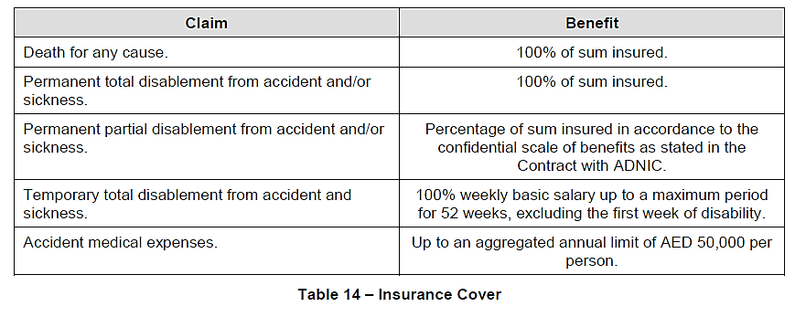

* **Health Insurance:**

1. ENEC provides comprehensive health insurance cover to all employees and their eligible dependents (employee’s spouse and dependent children only) that are resident in the UAE. The health insurance will be provided to the employee and his/her eligible dependents till the last working day.

2. ENEC’s current medical insurance scheme is provided through the National Health Insurance

Co. (Daman), and includes cover for in and outpatient treatment, plus dental and maternity benefits.

* **Road Vehicle Loans:**

1. ENEC employees who have completed the probation period and have been confirmed as permanent employees are entitled to interest-free road vehicle loans, subject to the value of the loan not exceeding their entitlement.

2. Road vehicle loans shall be repaid in equal installments over a maximum period of sixty (60) months. The installments are automatically deducted from the employee’s monthly salary until the full amount of the loan has been repaid.

3. Loans can be obtained for new and second hand road vehicles.

* **Leaves:**

The following sections list in detail the policies for different types of leave. Note that any type of leave shall be approved by the employee’s direct supervisor.

* **Annual Leave Entitlement:**

ENEC grants annual leave with full pay to all employees. The duration of annual leave entitlement, for each calendar year, depending on the employee’s grade, the annual leave varies between 26 to 36 working days.

* **Annual Leave Split:**

Taking into consideration work requirements and employees' wishes and preferences, employees may split their leave during the course of the year. Employees will, however, not be permitted to proceed on annual leave for a duration of more than thirty (30) working days at any one time, except for unavoidable circumstances and following approval by their supervisor.

* **Advance Leave Pay:**

Employees who are proceeding on annual leave will be entitled to one month salary in advance only if the applied and accrued annual leave entitlement is five (5) working days or more. In some cases, the employee has emergency circumstances in which he/she requires an advance salary, HR Director has the authority to evaluate and approve such emergency cases.

The employee shall submit the request at least two weeks prior to his/her leave or prior to required date. Any salary in advance will only be given for one month only and when the employee completed his/her probation period successfully.

* **Credit Leave:**
* **Working during Public Holidays:** Employees, who are required to work during public holidays, are eligible to have their leave records credited in lieu of the number of days worked in which each day will be credited with one day leave. Site based employees who are required to work during public holidays at Barakah site, will get a 1.5 credit leave for each day worked on a public holiday. The credit leave for days worked during public holidays will be added to the annual leave balance and will follow the annual leave carry forward and leave encashment policy.
* **Business/Training Mission inside the UAE**: Employees who have to attend business/training mission inside the UAE during a public holiday are entitled to credit leave in lieu of public holidays. The credit leave for days worked during public holidays will be added to the annual leave balance and will follow the annual leave carry forward and leave encashment policy.
* **Business/training Mission outside the UAE**: Employees on mission outside the UAE are eligible to have their leave records credited in lieu of UAE public holidays occurring during the mission regardless if it falls during weekend/site schedule rest day or not.
* **Accumulation/Carry forward of Annual Leave:**

Employees are allowed to carry forward ten leave days in their annual leave balance from year to year.

* **Leave Encashment:**

Unused leave that is not carried forward into the next year may be en-cashed on the basis of basic salary, only after the close of the relevant calendar year.

* **Work Injury Leave:**

1. A work injury is defined as a job-related disabling injury or illness.

2. Any work injury must be reported to HR as soon as possible.

3. Eligibility for work injury leave for all ENEC employees is subject to the validation of the designated medical authority and the evaluation and recommendation of the healthcare insurance company, Abu Dhabi Health Authority, and ENEC (if appropriate).

4. Work injury leave entitlement and payment during leave for all ENEC employees is as follows:

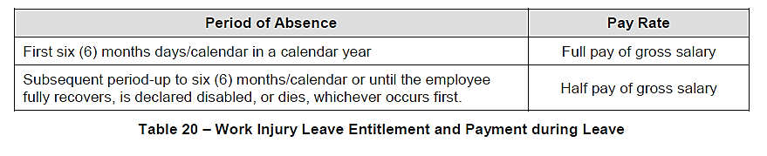

* **Maternity Leave:**

1. A female employee who has completed her probation period shall be eligible for forty five (45) calendar days’ maternity leave with full pay, to include the prenatal and postnatal periods.

2. A female employee nursing her child is entitled to time off not exceeding two hours per day during the eighteen (18) months following her delivery.

* **Paternity Leave:**

A Male employee is eligible for leave with full pay for three (3) working days in the event that a child is born to them.

* **Marriage Leave:**

All ENEC employees who have completed their probation period are entitled to three (3) working days’ paid leave once during their period of service at ENEC, for their own legal marriage.

* **Compassionate Leave:**

1. Compassionate leave is defined as leave in the event of the death or imminent death of an employee’s immediate relatives, which warrants special consideration of paid absence from work.

2. All ENEC employees are eligible for compassionate leave with full pay in the event of the death or imminent death of an immediate relative. The entitlement and conditions are given below:

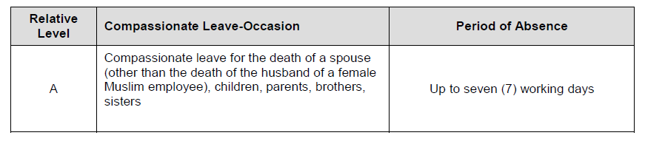

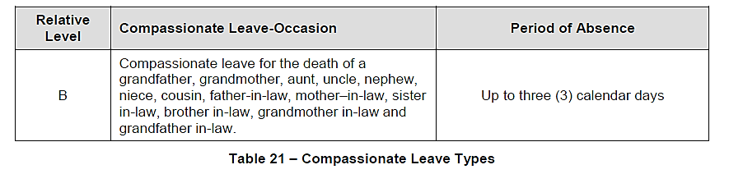

* **TRAINING AND BUSINESS MISSIONS:**

1. ENEC covers business and training mission expenses for ENEC employees who are authorized to attend business and training missions. Training includes courses, professional certifications, conferences, seminars, workshops, forums or any other session/class for which there are registration and/or attendance fees.

2. Business and training missions can be inside or outside the UAE.

3. The employee commissioned for a mission shall receive a daily per Diem allowance, as determined for his/her grade and according to the duration and location of the mission.

4. For business/training missions, ENEC provides air tickets (for outside UAE), accommodation, a per diem allowance, and visa costs coverage for overseas travel.